

CLIENT: | Garber CDJR | PHONE #:
SPOT: | CJ-GAR-T210501 May Jeep Freedom | FAX # : | (NEW CAR)
LENGTH: | :30 | SALES REP: | Kim G.
DATE: | 5/6/2021 | PRODUCER | A. Dennis

GRAPHICS | Video | AUDIO
Garber Chrysler Logo  (Chrysler, Dodge, Jeep, Ram Logos)  www.GarberCDJR.com  Bay Road - Saginaw  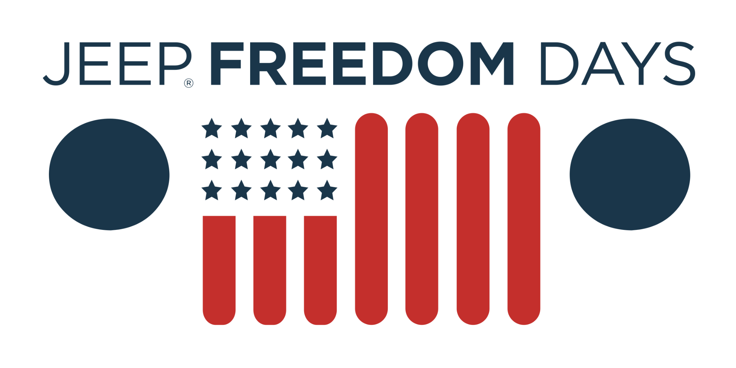  Over 200 Vehicles Arriving Soon  Reserve Now (Icon)  2021 Jeep Renegade Limited  Lease From Just $199/mo  Stock# MPM08412. Lease for 24 months, 10,000 miles per year for qualified lessees with approved credit. $2,999 due at signing.Taxes, and optional equipment extra. Must qualify for Employee Pricing and Lease Loyalty. Other restrictions apply. See dealer for details. Offer ends 6/1/21.  2021 Jeep Cherokee  Lease From Just $258/mo  Stock# MD231094. Lease for 36 months, 10,000 miles per year for qualified lessees with approved credit. $999 due at signing.Taxes and optional equipment extra. Must qualify for Employee Pricing, Lease Loyalty, and Lease Conquest, and First Responder offers. Other restrictions apply. See dealer for details. Offer ends 6/1/21.  2021 Ram 1500 Big Horn Quad Cab 4x4  Save Up To $11,300 Off MSRP  Original MSRP $46,020. Stock# MN600025. Requires financing through Chrysler Capital with approved credit. Not all customers will qualify.. Must qualify for all available incentives and rebates. Other restrictions apply. See dealer for details. Offer ends 6/1/21.  Garber Chrysler Logo  (Chrysler, Dodge, Jeep, Ram Logos)  www.GarberCDJR.com  Bay Road - Saginaw | 2021 Jeep Freedom Days Event (Logo)  Photo: 2021 Jeep Renegade  Photo: 2021 Jeep Cherokee  Photo: 2021 Ram 1500 Big Horn Quad Cab | Announcer: (:30)  Tread your own path toward savings, during Jeep Freedom Days!  Now at Garber Chrysler Dodge Jeep Ram!  Get incredible deals on over 200 new vehicles arriving soon - ready for reservation!  Or get a better deal and drive a new Jeep Renegade Limited today! Now from just $199 a month!  Lease a new Jeep Cherokee for as little as $258 a month!  Or buy a new Ram 1500 Big Horn and get up to $11,300 off MSRP!  Only at Garber Chrysler Dodge Jeep Ram! Bay Road in Saginaw!

